HACKER RANK (PYTHON PROGRAMMING)

1 . 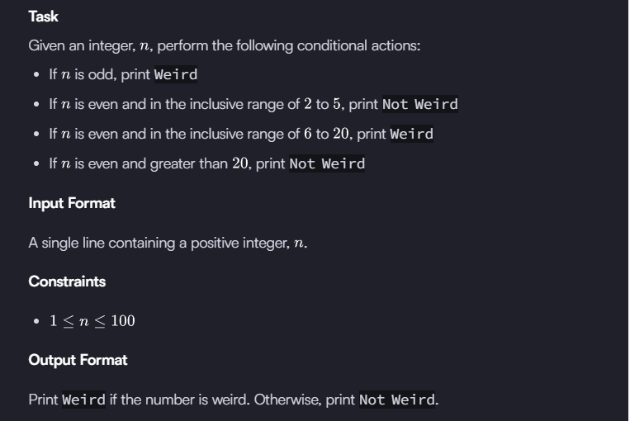
Print Weird if the number is weird. Otherwise, print Not Weird.
Sample Input 0
3
Sample Output 0
Weird

Source Code :

n = int(input().strip())
if n % 2 != 0:
print("Weird")
elif 2 <= n <= 5:
print("Not Weird")
elif 6 <= n <= 20:
print("Weird")
else:
print("Not Weird")

2 . Arithmetic operator
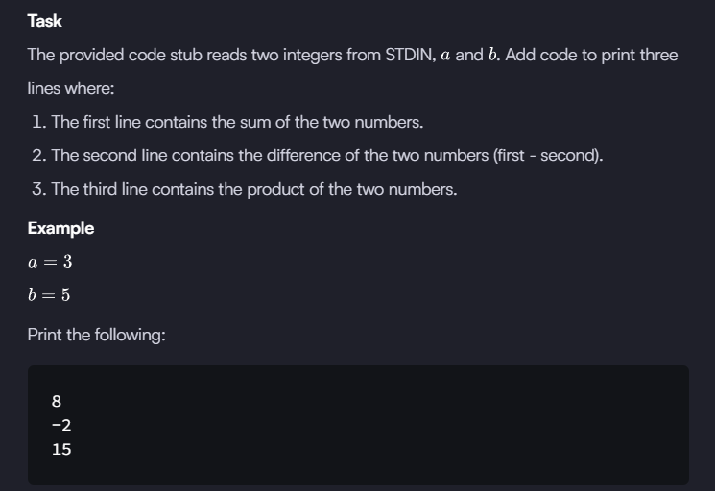
Sample Input 0
3
2
Sample Output 0
5
1
6

Source Code :
a = int(input().strip())
b = int(input().strip())

print(a + b) # sum
print(a - b) # difference
print(a * b) # product

3 . Python: Division
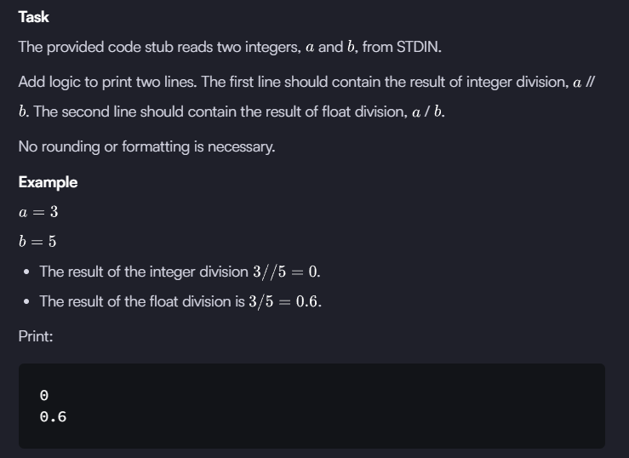

Source Code :

def main():
# Read two integers from input
a = int(input())
b = int(input())

# Integer division
print(a // b)

# Float division
print(a / b)

if __name__ == "__main__":
main()

4 . In this challenge, the user enters a string and a substring. You have to print the number of times that the substring occurs in the given string. String traversal will take place from left to right, not from right to left.
NOTE: String letters are case-sensitive.
Input Format
The first line of input contains the original string. The next line contains the substring.
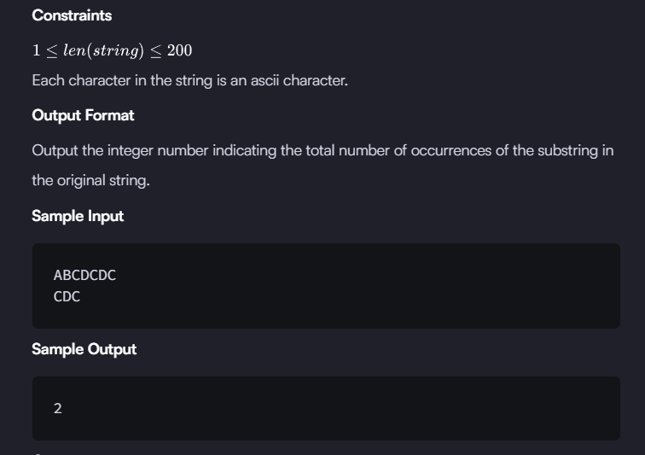

Source Code :
def main():
# Read the original string
text = input().strip()

# Read the substring
sub = input().strip()

count = 0
# Traverse the string from left to right
for i in range(len(text) - len(sub) + 1):
if text[i:i+len(sub)] == sub:
count += 1

print(count)

if __name__ == "__main__":
main()

5 . Write a function :
n extra day is added to the calendar almost every four years as February 29, and the day is called a leap day. It corrects the calendar for the fact that our planet takes approximately 365.25 days to orbit the sun. A leap year contains a leap day.
In the Gregorian calendar, three conditions are used to identify leap years:
- The year can be evenly divided by 4, is a leap year, unless:
  - The year can be evenly divided by 100, it is NOT a leap year, unless:
    - The year is also evenly divisible by 400. Then it is a leap year.
This means that in the Gregorian calendar, the years 2000 and 2400 are leap years, while 1800, 1900, 2100, 2200, 2300 and 2500 are NOT leap years. Source
Task
Given a year, determine whether it is a leap year. If it is a leap year, return the Boolean True, otherwise return False.
Note that the code stub provided reads from STDIN and passes arguments to the is_leap function. It is only necessary to complete the is_leap function.

Source Code :
def is_leap(year):
leap = False

# Write your logic here
if (year % 4 == 0 and year % 100 != 0) or (year % 400 == 0):
leap = True
return leap

year = int(input())
print(is_leap(year))

6. Print Function :
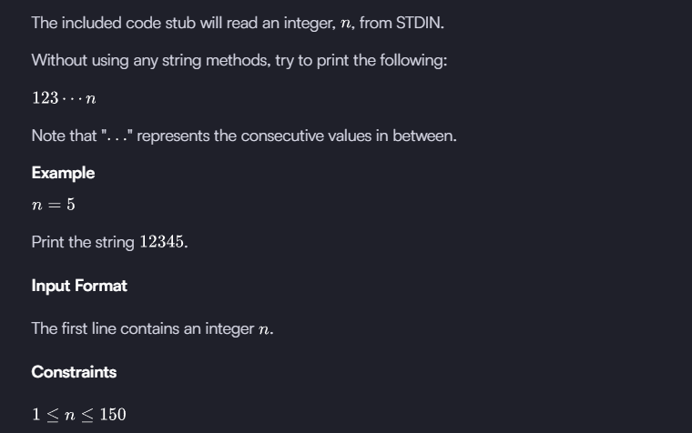
Output Format
Print the list of integers from 1 through n as a string, without spaces.
Sample Input 0
3
Sample Output 0
123

Source Code :
def main():
n = int(input()) # Read integer input

# Print numbers from 1 to n in one line without spaces
for i in range(1, n + 1):
print(i, end="") # end="" avoids spaces/newlines

if __name__ == "__main__":
main()
7 . List Comprehension :
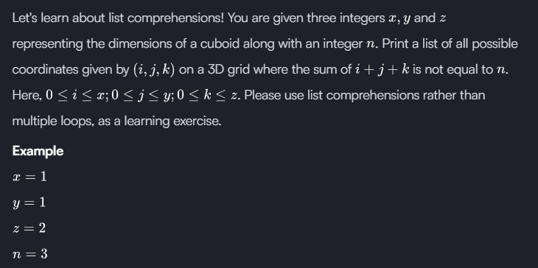
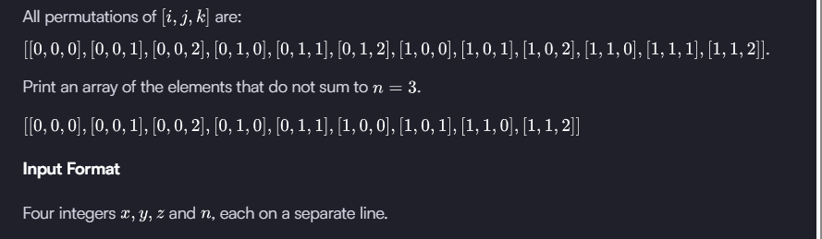
Source Code :
x = int(input())
y = int(input())
z = int(input())
n = int(input())

result = [[i, j, k]
for i in range(x + 1)
for j in range(y + 1)
for k in range(z + 1)
if i + j + k != n]

print(result)
8 . Nested List :
Given the names and grades for each student in a class of N students, store them in a nested list and print the name(s) of any student(s) having the second lowest grade.
Note: If there are multiple students with the second lowest grade, order their names alphabetically and print each name on a new line.
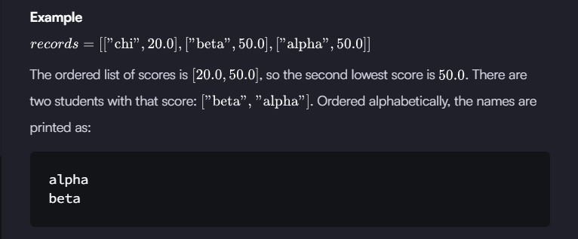
Sample Input 0
5
Harry
37.21
Berry
37.21
Tina
37.2
Akriti
41
Harsh
39
Sample Output 0
Berry
Harry

Source Code :
def main():
records = []
n = int(input()) # Number of students

# Read student records
for _ in range(n):
name = input().strip()
score = float(input())
records.append([name, score])

# Extract unique scores and find the second lowest
scores = sorted({score for _, score in records})
second_lowest = scores[1]

# Get names of students with the second lowest score
result = [name for name, score in records if score == second_lowest]

# Print names alphabetically
for name in sorted(result):
print(name)

if __name__ == "__main__":
main()

Medium :

1 . Merge The Tools :
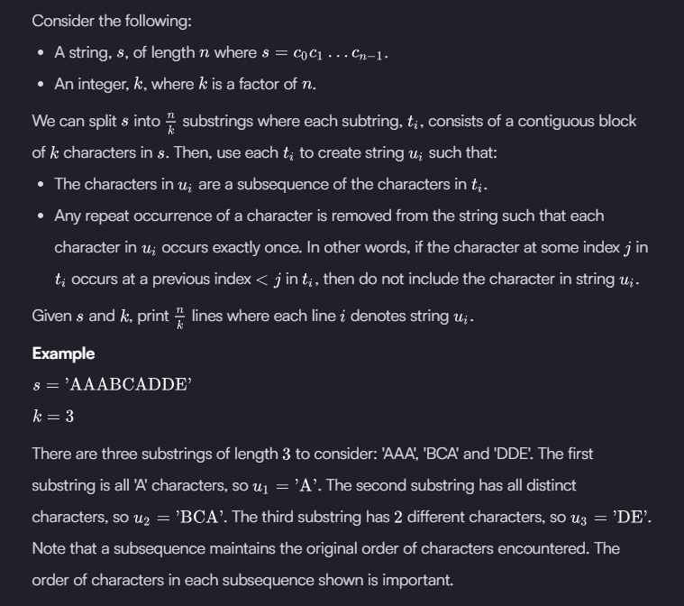
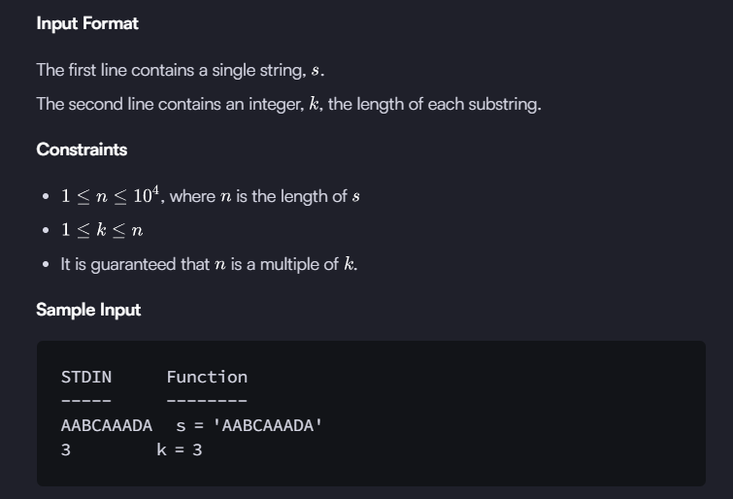
Source Code :
def merge_the_tools(string, k):
# your code goes here
for i in range(0, len(string), k):
substring = string[i:i+k]
result = ""

for ch in substring:
if ch not in result:
result += ch

print(result)

if __name__ == '__main__':
string, k = input(), int(input())
merge_the_tools(string, k)

2 . Loops :
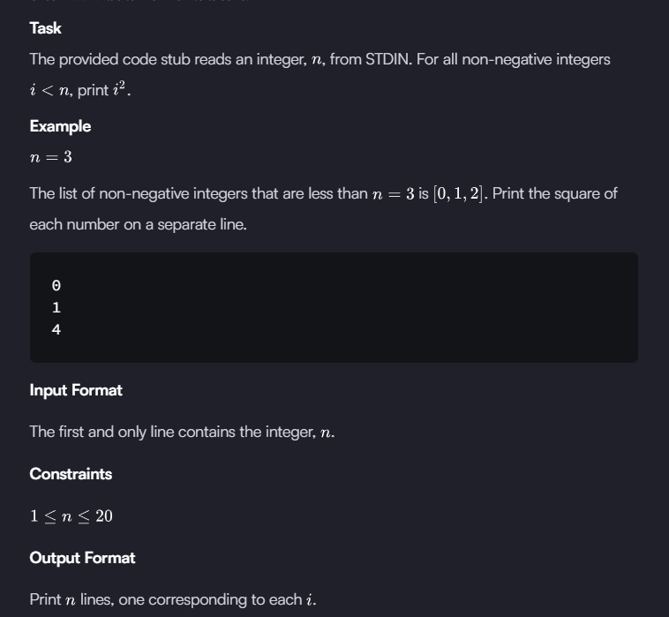

Source Code :
n = int(input().strip())

for i in range(n):
print(i * i)

